Διαχείριση Δικτύων Βασισμένων στο Λογισμικό
6^{ο} εργαστήριο: “Mininet walkthrough”

ΟΝΟΜΑΤΕΠΩΝΥΜΟ:
Α.Μ.:

Για να ξεκινήσετε χρειάζεστε:
- Το Ubuntu VM (username: Eirini, pwd: mininet): https://drive.google.com/file/d/1AGwMWK7A_4O-TFIbDbrAQcxmqbtDT3qk/view?usp=sharing
- Ένα virtualisation system όπως το VirtualBox: https://www.virtualbox.org/wiki/Downloads

Κατεβάστε το VM στο φάκελο /opt στον υπολογιστή του εργαστηρίου (ή αντιγράψτε το εκεί). Στη συνέχεια αποσυμπιέστε το αρχείο: “unrar x SDN-HUA.rar”. Note: Ο φάκελος opt είναι στο “Other locations”.
Πληκτρολογήστε “su user”, και θα εισάγουμε τον admin κωδικό (από τον διδάσκοντα).
Πληκτρολογήστε “chmod 777 SDN-HUA.vdi”.

Ανοίξτε το VM μέσω VirtualBox (“New”, “Type”: Linux, “Version”: Ubuntu 64-bit → “Use an existing virtual hard disk file” και εντοπίστε το “.vdi” file.

Virtual Box: Go to Settings -> General -> Advanced -> Set to “Bidirectional” both available options. This allows copy-paste between host PC and VM.

Now follow the Walkthrough to get familiar with Mininet commands and typical usage:

http://mininet.org/walkthrough/

While following the Walkthrough answer the following questions (which belong to the Walkthrough) by providing respective screenshots. Note that the Walkthrough provides details which will help you answer these questions.

Q1. Provide the output of the following command, to prove that you have successfully installed Mininet:
$ sudo mn

Q2. Verify that you can ping among all hosts:
mininet> pingall

Q3. Run a regression test:
$ sudo mn --test iperf

Q4. In the Mininet walkthrough it is written that: “You should see OpenFlow control traffic. The first host ARPs for the MAC address of the second, which causes a packet_in message to go to the controller. The controller then sends a packet_out message to flood the broadcast packet to other ports on the switch (in this example, the only other data port). The second host sees the ARP request and sends a reply. This reply goes to the controller, which sends it to the first host and pushes down a flow entry.” Choose “any” interface when opening the program.

Add the respective screenshot from Wireshark.
sudo wireshark &
h1 ping -c 1 h2

Q5. Create a simple HTTP server at h1 and connect h2 to this server.
mininet> h1 python -m SimpleHTTPServer 80 &
mininet> h2 wget -O - h1
...
mininet> h1 kill %python

Q6. In the simplest topology conduct traffic control by setting bandwidth = 10Mbps – 50Mbps – 100Mbps and display the results using iperf.
Then, control the delay of all links by setting delay = 10ms – 20ms – 50ms and log the results using ping. 6 screenshots are therefore needed.
EXAMPLE (you have to adopt the commands):
$ sudo mn --link tc,bw=10,delay=10ms
mininet> iperf
...
mininet> h1 ping -c10 h2

You may observe a pattern in the actual delays (please comment).

Q7. Prove the POX controller is running and is connected to Mininet:
$ sudo mn --controller=remote,ip=127.0.0.1,port=6633

$ cd ~/pox
$ ./pox.py forwarding.l2_learning

Q8. Using Mininet, create the following topologies:
- Single, with 5 hosts
- Linear, with 7 hosts
- Tree, with 27 hosts (3 levels deep)
Show the commands, and respective terminal outputs.

Q9. Add any missing lines of Python code into the file “custom-topo.py”, in order to create the following custom topology. Use the Mininet Python API reference manual to find the necessary functions: http://mininet.org/api/classmininet_1_1net_1_1Mininet.html

Then use the following command to run it and show the output:

sudo mn --custom ~/mininet/custom/custom-topo.py

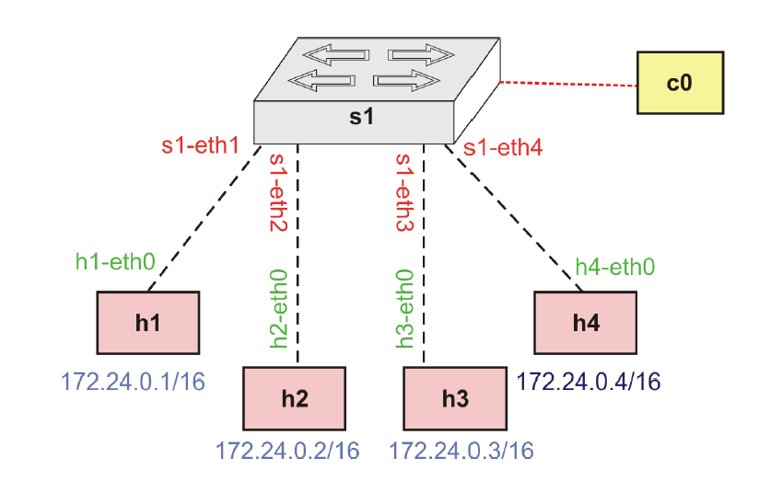
Q10. Now we will work with MiniEdit. Refer to the manual: https://www.brianlinkletter.com/2015/04/how-to-use-miniedit-mininets-graphical-user-interface/

Run:
sudo ~/mininet/examples/miniedit.py

Select: Edit -> Preferences -> “Start CLI” option

Using MiniEdit, create the same topology as before (including IP addresses at hosts). Don’t forget to add the Controller! Note that you may use the Edit -> Properties -> IP Base option. Then “Run” this topology and present here both the MiniEdit window and the Mininet output. Also run any command that shows the configured IPs.

