Διαχείριση Δικτύων Βασισμένων στο Λογισμικό
7^{ο} εργαστήριο: “POX Controller”

ΟΝΟΜΑΤΕΠΩΝΥΜΟ:
Α.Μ.:

Part 1: Create a hub application.

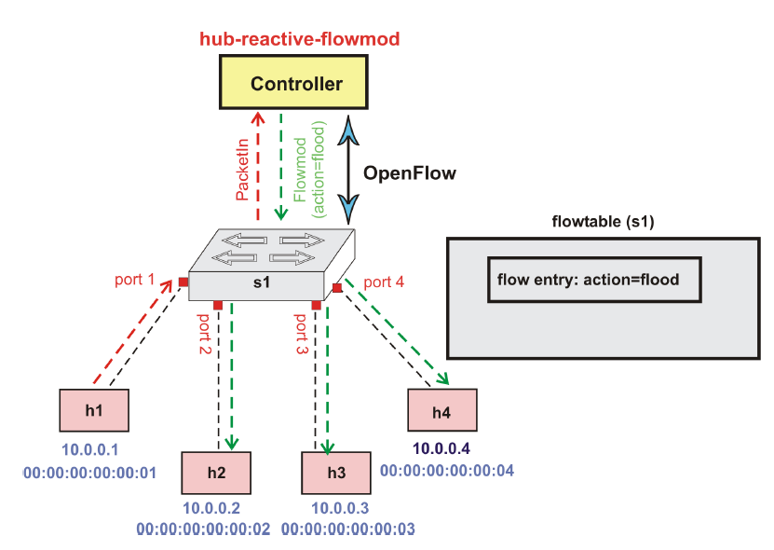

A hub is used for connecting devices in LAN. When a packet arrives at hub, it is sent through all other ports (it means hubs works by flooding the packets) except the incoming port.

Perform the following steps and answer the questions in blue.

Step 1: Create the hub application in “/home/pox/pox/forwarding”: Copy the file “hub-reactive-flowmod.py” in this directory and fill in the missing code as indicated in this file.

Write below the full code, highlighting with colour the code you have added: (1)

Step 2: Run the hub application. Be careful to be in the correct directory.

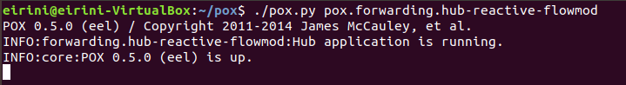

Step 3: Create a topology of 4 hosts and 1 switch (use “- -controller remote option”).

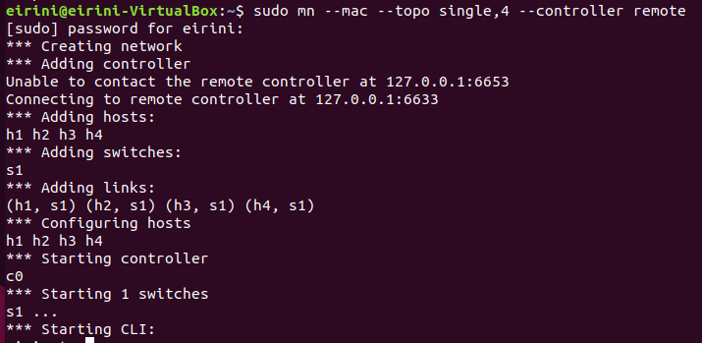

Step 4: Test connectivity.

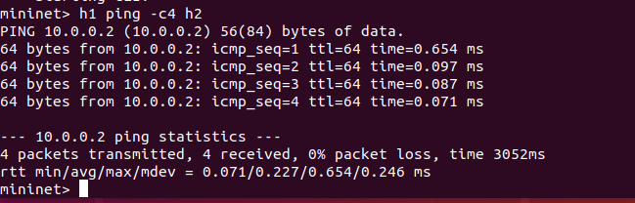

Question: Why does the first packet take more time? (0.5)

Step 5: Check flow table entry at the switch.

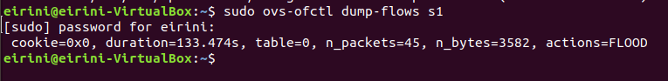

Question: What do you see? (1)

Step 6: Ping from h1 to h4 and dump the output from h2, h3 and h4 to prove that flooding is indeed taking place (verify hub behavior). Use the command xterm h1 h2 h3 h4 to open four terminals.

Provide the following four screenshots from your computer, to prove you have successfully created the hub application. (1)

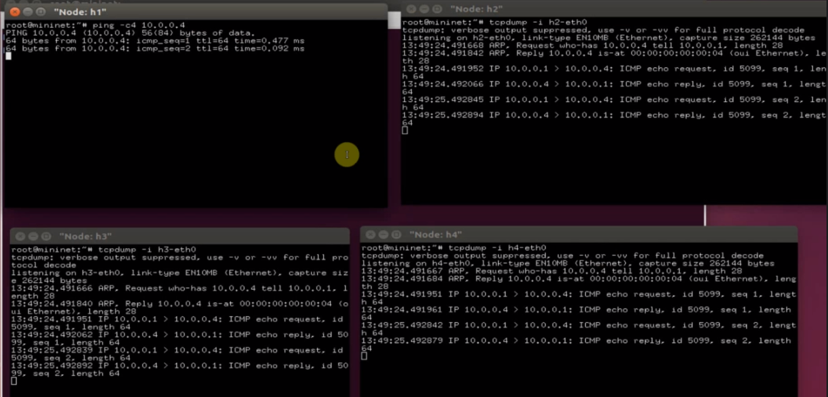

Question: Replace “PacketIn” with “ConnectionUp” and “_handle_PacketIn” with “_handle_ConnectionUp”. Do any other adjustments if needed and save the file as “hub-proactive-flowmod.py”. What is different as compared to the previous reactive approach with respect to the establishment of the flow table entry (i.e., when can you see the FLOOD action in the flow table)? (0.5)

Part 2: Create a switch application.

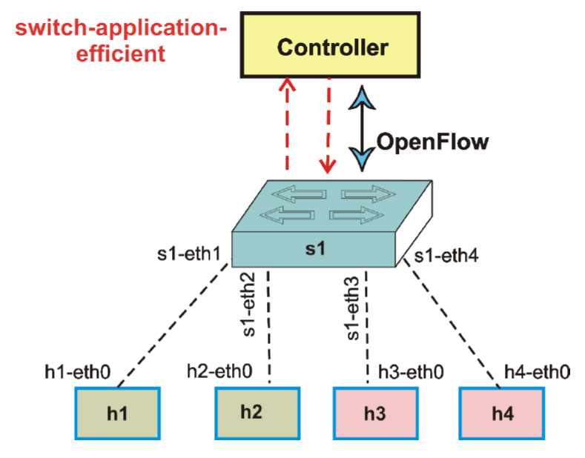

When we will run our switch application “switch-application-efficient” on top of POX controller, two tables will be maintained. One table will be maintained at the controller and another table will be maintained at the switch. The table maintained at the controller will be “mac to port table” The table maintained at the switch will contain flow entries. Initially both tables will be empty.

Step 1: Create the switch application in “/home/pox/pox/forwarding”: Copy the file “switch-application-efficient.py” in this directory and fill in the missing code as indicated in this file.

Write below the full code, highlighting with colour the code you have added: (1)

Provide screenshots for all the following steps: (2)

Step 2: Run the switch application.

Step 3: Create a topology of 4 hosts and 1 switch (use “- -controller remote option”).

Step 4: Test connectivity (ping to h4 from h1).

Step 5: Check flow table entry at the switch.

Step 6: Verify switch behaviour.

Part 3: Create a firewall application.

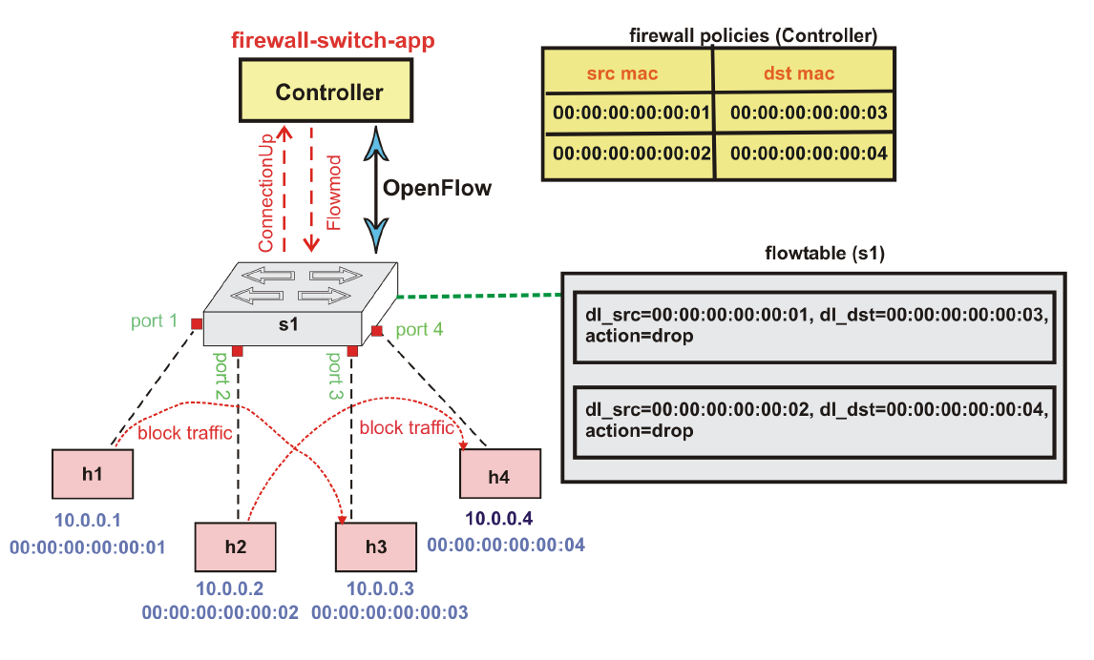
We want to block traffic from mac address “00:00:00:00:00:01” to “00:00:00:00:00:03” and from “00:00:00:00:00:02” to “00:00:00:00:00:04” (see “firewall-mac-policies” excel file).

Step 1: Create the firewall application in “/home/pox/pox/forwarding”: Copy the file “firewall-switch-app.py” in this directory and fill in the missing code as indicated in this file.

Write below the full code, highlighting with colour the code you have added: (1)

Provide screenshots for all the following steps: (2)

Step 2: Run the firewall application.

Step 3: Create a topology of 4 hosts and 1 switch (use “- -controller remote option”).

Step 4: Test connectivity (ping to h4 from h1).

Step 5: Check flow table entry at the switch.

Step 6: Verify firewall behaviour using ping commands among all pairs.

