Διαχείριση Δικτύων Βασισμένων στο Λογισμικό
8^{ο} εργαστήριο: “Open vSwitch”

ΟΝΟΜΑΤΕΠΩΝΥΜΟ:
Α.Μ.:

Creating applications without using a Controller
(1.5 point all but last question)
Consult the “Without-controller” file.
The ovs-ofctl program is a command line tool for monitoring and administering OpenFlow switches. It can also show the current state of an OpenFlow switch, including features, configuration, and table entries.
Conduct the following experiments using –controller none option when creating your Mininet topology!

Part 1: Hub
Create the following hub application using ovs-ofctl.
- Show a screenshot proving the installed flow entry (flood) in the switch.
- Show a screenshot that verifies the hub behaviour (showing all 4 hosts/terminals).
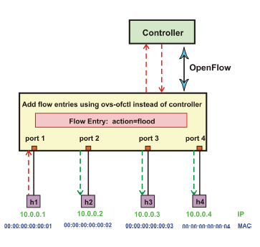

Part 2: Switch
Create the following switch application using ovs-ofctl.
- Show a screenshot proving the five installed flow entries in the switch.
- Show a screenshot that verifies the switch behaviour when h1 pings h2 (showing all 4 hosts/terminals).
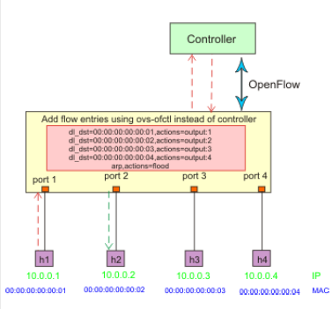

Part 3: Firewall
Using the logic of the creation of the switch application using ovs-ofctl, create a firewall application, as shown in the next figure (i.e., h1 should not be able to ping h2 but h2 should be able to ping h1).
- Show a screenshot proving all installed flow entries in the switch.
- Verify the firewall behaviour using pingall and copy the screenshot here.
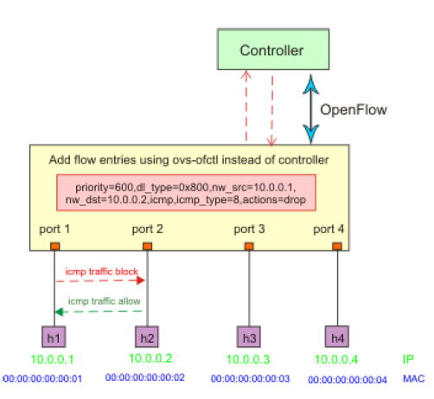
Are we able to ping from h2 to h1 (i.e., opposite direction)? How can we control this? (1 point)
Hint: First create all 5 flow table entries, as in the switch application, with “priority=500”. Then, to add the firewall rules, add a new flow table entry with higher priority (e.g. priority=600), with the corresponding nw_src and nw_dst addresses, as well as the respective action to drop packets (consult the red box in the figure).

