Διαχείριση Δικτύων Βασισμένων στο Λογισμικό
9^{ο} εργαστήριο: “RYU Controller & MiniNAM”

ΟΝΟΜΑΤΕΠΩΝΥΜΟ:
Α.Μ.:

MiniNAM: A Network Animator for Visualizing Real-Time Packet Flows in Mininet

MiniNAM is a utility that provides real-time animation of any network created by the Mininet emulator. Mininet is capable of emulating both traditional and software defined networks, however it does not provide a tool to visually observe and monitor the packets flowing over the created network topology. MiniNAM includes all the components required to initiate, visualize and modify Mininet network flows in real-time.

MiniNAM provides a graphical user interface that allows dynamic modification of preferences and packet filters: a user can view selective flows with options to color code packets based on packet type and/or nodes (hosts). This establishes MiniNAM as a very powerful tool for debugging network protocols or teaching, learning and understanding network concepts.

Visit https://www.ucc.ie/en/misl/research/software/mininam/ and read the full manual. Summary:

If you are NOT using “Eirini” VM:
- Install and start MiniNAM:

sudo git clone https://github.com/uccmisl/MiniNAM

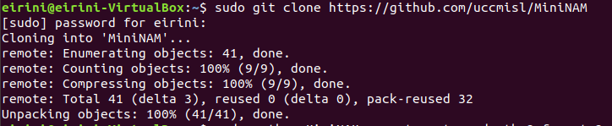

sudo apt-get install python-imaging OR sudo apt-get install python-imaging-tk

cd MiniNAM

sudo python MiniNAM.py

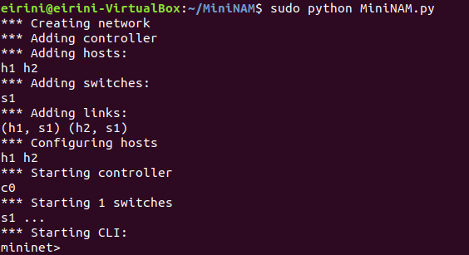

ALL:
You should now have opened the graphical environment of MiniNAM. Provide a screenshot to prove that.

Part 1: NAT
Run:

cd MiniNAM/Examples/NAT

sudo python MiniNAM.py --config conf.config --custom goodNAT.py --topo mytopo

Right click h1:

h1# ping 10.0.0.100 -c 3

Provide two screenshots from MiniNAM showing the NAT functionality (change of IP address by the router).
You can “play” with the Option: Edit → Preferences → “Show IP address on packets” Source or Destination.

Part 2: ROUTING
Run:

cd ryu/ryu/app

ryu-manager simple_switch_stp_13.py

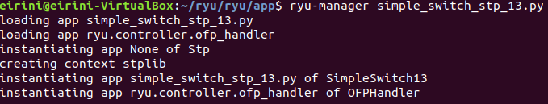

cd MiniNAM/Examples/Routing
sudo python MiniNAM.py --custom spanning_tree.py --topo mytopo --controller remote

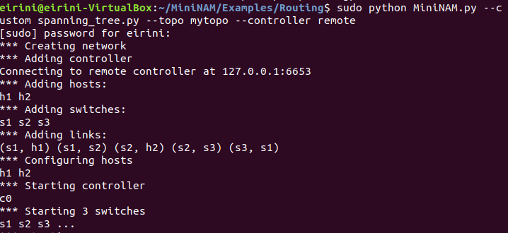

WAIT for Controller.

At h1 terminal:
ping 10.0.0.2 -c 10

Provide a screenshot from MiniNAM showing the Routing functionality (packets flowing).

Now right-click on the link between s1 and s2 and click on Link Down to simulate a broken link (or type “link s1 s2 down”). The controller will re-configure switches to update the path. WAIT for a while.
Do “h2 ping h1” and you can observe ICMP packets flowing through the alternate path.
Provide a respective screenshot.
(Note: this might not work properly after a while – seems to be a bug in the code).

NOTE: If mininet is stuck at any time, kill it using “sudo mn -c”

