Διαχείριση Δικτύων Βασισμένων στο Λογισμικό
10^{ο} εργαστήριο: “Traffic tests”

ΟΝΟΜΑΤΕΠΩΝΥΜΟ:
Α.Μ.:

Reply 5 out of 6 questions! 2 points each.

Go to https://learning.knetsolutions.in/docs/ryu/#17-traffic-tests---part1 – Section 17: Traffic Tests - Part1.

Copy l4_switch.py file into ryu/ryu/app directory.

Then run the following tests:

TCP Tests
- Traffic test from h1 to h4
- Bidirectional Traffic test h1 to h4 (sequentially).
- Bidirectional Traffic test h1 to h4 (parallel).
- Traffic test from h1 to h4 with Multiple Sessions.

Provide 4 screenshots with the previous measurement results (not the flow table entries).

UDP Tests with IPERF
Provide a screenshot with the measurement result.

Video Stream Traffic Testing
If you are not using “Eirini” VM: Type: sudo apt-get install vlc vlc-bin

Place the video bbb_sunflower in your home/eirini/Downloads directory (or any other directory).

Provide a screenshot like the following, proving that you have managed to stream the video of your choice:

Change to “su – eirini” the respective command and also use the correct directory in the “cvlc command”.

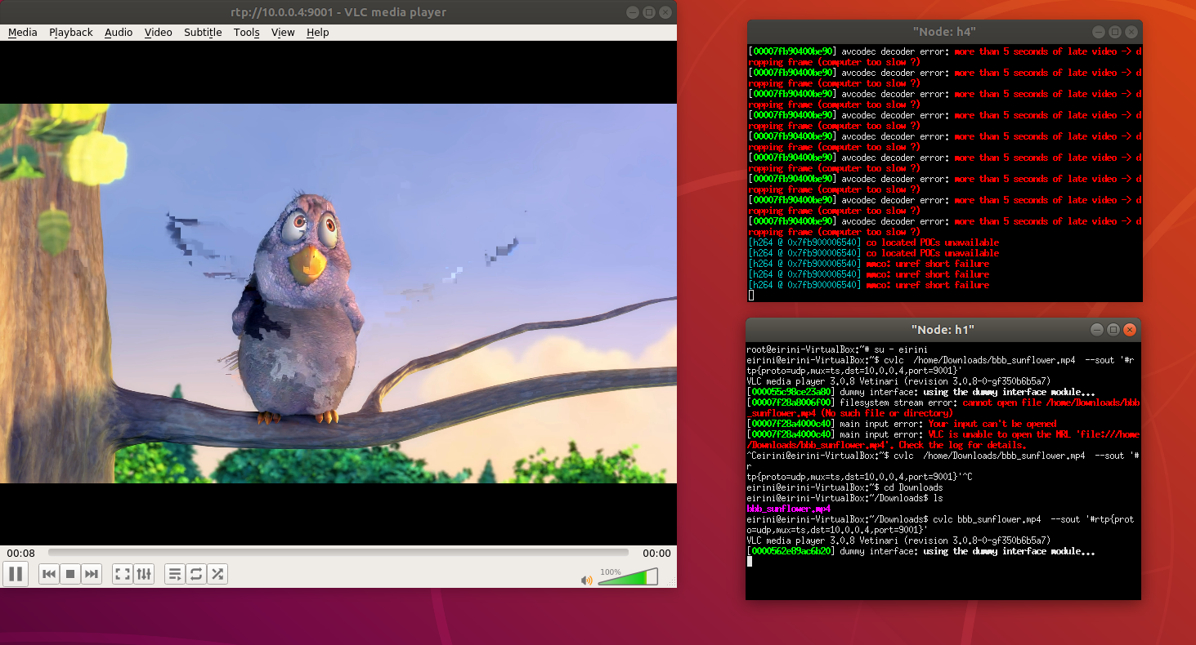

D-ITG Distributed Internet Traffic Generator
Open https://learning.knetsolutions.in/docs/ryu/#18-traffic-tests-with-ditg - Section 18: Traffic Tests with DITG. Only UDP Part.

Run this test and show the output of the receiver.log file.

