http://www.mfa.gr/en/visas/visa-types/national-visas.html

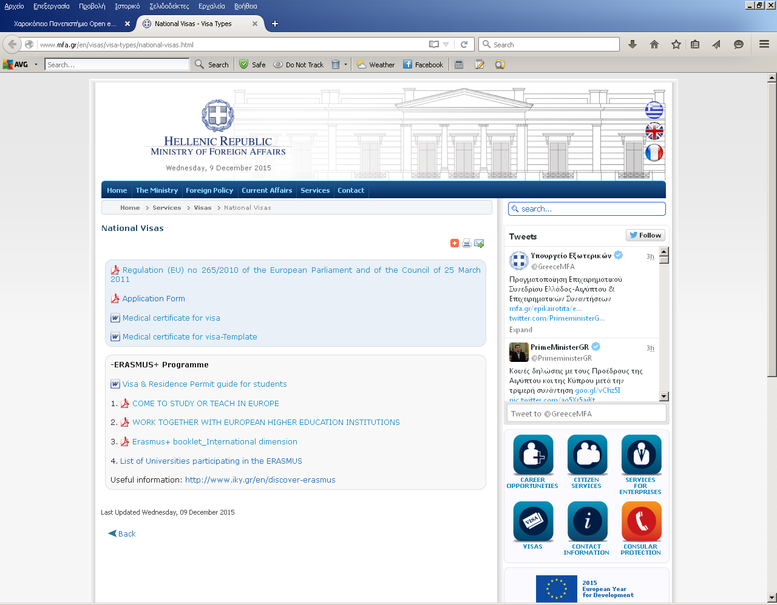

http://www.mfa.gr/theoriseis-eisodou-visas/eidi-theoriseon/ethnikes-theoriseis.html

